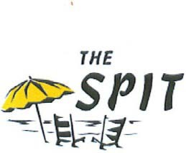

Willoughby Civic League
P.O. Box 8654
Norfolk, VA 23503

Membership Form

Name:

Address:

Telephone: H) C)

E-mail:

Are you active duty military or active duty reserve?

Do you wish to serve on a committee?

If yes, please indicate by checking below which committee you are interested in. Neighborhood Improvement: Conservation:
Community Activities: Ways & Means: Membership:

Clean Willoughby: Neighborhood Watch:

Membership is $10 per person per year and may be paid by check and mailed with this completed form to the address above, or paid by cash or check at any civic league meeting.

The civic league meets September – June at 7 p.m. on the 2nd Thursday of the month at the American Legion Post at 850 W. Ocean View Ave.

Please make checks payable to: Willoughby Civic League. THANK YOU!

willoughbycivicleague@gmail.com

